**AccessibleUK 1**

**Igor Jankowski**

**c2053730**

**Situation**

The project me and my group has been assigned to work on aims to improve on existing website by reworking it from ground up to make it run smoother and be more accessible to the user. The platforms aim is to assist individuals with disabilities in finding relevant access information about various locations that offer accessibility features like for example: level access, pet-guide friendliness, changing places, sensory gardens, or dietary needs. The primary issue identified this project is aiming to resolve the lack of comprehensive accessibility details, with 97% of businesses not providing such information. The client is passionate about the project and estimates that there is about 16 million people with disabilities in UK who require this information about various businesses. During the first meeting with the client, they specified the main priorities they expect of us to include in the new and improved website. One of the most important tasks specified by the client during the meeting was the improvement of websites loading times and overall performance due to the current website being slow. Another project requirement given to us by the client was creating a new database for Laravel based on the current websites database structure to keep the database structure similar but optimise it with use of Laravel instead of WordPress which would fix the previously stated issue of the website having slow long loading times. There were also many smaller but not less important improvements suggested by the client during the first meeting which include: Generating a qr code for each business tutorial, increasing the annual fee for the service from current £50 to £100, making the website mobile friendly and enabling an autosave feature which would save the progress made on the website (for example while filling in the business form) in case the computer lost the connection to the internet. One of the issues we discussed as a group after the first meeting with the client was the amount of small seemingly minimal impact features the client included in their requirements; this was an issue because at first after collecting our client requirement notes together into a one document we quickly realised that the amount of expected features would surerely exceed the amount of work that could be done in the time of a sprint week. However, we overcame this issue by prioritizing getting the core elements, such as essential pages and fundamental functionalities, up and running by the time of the first client presentation while leaving the other clients required features for later.

**Tasks**

In order to plan the work that had to be done to build the application we as a group have set up a to do list where each of the group members got assigned a distinct set of tasks, the tasks would incluse things like: each of the pages that needed to be created for the new website, new or rebuilt features that would be implemented into the application (for example search bar or business form) and the documentation and planning of work like user stories and diagrams. One thing we all worked on as a group was the low fidelity prototype of the application, we created using the MockPlus tool, this was a very helpful planning tool because it allowed us to unite our vision for the project by creating a prototype that resembled the final product and avoid the conflicts caused by different visions of the application further down the development cycle. Another planning method that was very helpful with building the website was the creation of user personas as well as user stories. The user stories allowed us to identify the needs and expectations of our target audience which was very important in this case because the website had to be accessible to the wide audience with various disabilities. Ensuring that the features we developed were relevant and useful User personas helped us visualize our users more concretely, making it easier to tailor the design and functionality of the application to their specific requirements. For the back-end part of this project we created various diagrams that helped a lot during the development of the website, one of such artefacts was the EDR diagram we based the database of the project on. This diagram allowed us to clearly define the relationships between different entities in our database, ensuring a well-structured and efficient data model. By visualizing the database schema beforehand, we were able to prevent potential issues related to data integrity and redundancy, making the development process smoother. In addition to the EDR diagram, we also created a C4 diagram to better understand and visualize the overall architecture of the application. The C4 model allowed us to break down the system into multiple layers starting from the overall structure of the website and progressively detailing the backend features like Api's and database. Regular team meetings and discussions were also an essential part of our planning process. By consistently reviewing our progress, addressing any roadblocks, and adapting our plans, when necessary, we maintained a steady workflow and ensured that everyone was aligned with the project’s goals.

**Actions**

At the beginning of the sprint week i have encountered a major issue with university computers, the client required us to work on Laravel php framework which i could not install on the university machine due to restrictions which set me back one day until i got access to the virtual machine. The next day i tried installing the Laravel framework on the virtual machine however again i encountered problems, for some reason the website would not load CSS correctly as well as all the routing between the pages was not working on my machine. At that point I have decided to change my approach to the work until i resolve the issue to not waste any more time. While my groupmates started building the pages of the website based on the previously made MockPlus prototype I started to work on other artifacts we would use later towards the end of the sprint week. I started with user stories that outlined different interactions users would have with the application. These user stories helped define the key features and ensured that our development aligned with the client’s requirements. After completing the user stories, I moved on to creating diagrams such as the Entity-Relationship Diagram (ERD) and C4 diagrams, which provided a structured overview of the database and system architecture. These artifacts were crucial for our development process and avoiding issues later in the sprint. While working on these, I also continued troubleshooting my Laravel setup. After researching potential solutions and discussing the issue with my groupmates we have found a short-term solution that allowed me to work on the actual website however required me to repeat the set-up process at the beginning of each day. On the last day of the sprint week i got to work on the payment page for the website which allowed to user to set up an annual payment of £100 per year fee for the service. The page included a form which the user had to fill in with information such as:: address, card details, and contact information. To ensure security, we implemented basic validation on the form fields, preventing users from submitting incomplete or incorrect data. Despite the initial challenges with Laravel, I was able to contribute effectively by adapting to the situation and focusing on tasks that did not require immediate access to the framework. Once I had a temporary workaround, I was able to integrate my work into the project and help finalize key components before the sprint concluded.

**Result**

Overall, i believe that this was a very productive sprint week for our group, we managed to produce a working website with the required core features like: crucial pages, search bar, payment form, business form and autosave feature as well as many artifacts required for documenting the development process like: Low fidelity prototype, User Personas, User Stories, EDR diagram, C4 diagrams or even the to do list which helped a lot with organising the tasks that had to be completed by the end of the sprint week in order to deliver a good product to the client. Even though i encountered an unexpected issue at the beginning of the sprint week which caused me to change my approach to the task by switching my focus to creating the artifacts mentioned earlier instead of work on the website itself for most of the week. However, i still managed to work on the payment page on the last day of the sprint week which allowed me to contribute both on the documentation part of the task as well as the development side. The client was pleasantly surprised with the scope of our website and the fact that our project included most of the client’s requirements or at least the “work in progress” versions of the features. The one comment i can remember the client had on the website was the fact that we did not yet set up the picture gallery she asked for and instead we had a placeholder picture that represented how the final product would look like. One challenge I faced during the previous sprint was working with Laravel on the university computers. Due to system restrictions, I had to reinstall everything each day, which significantly slowed down my workflow. However, after troubleshooting and finding a more efficient way to handle this issue on the last day of the week, I feel much more prepared for the next sprint. With this experience, I am confident that I will be able to work more efficiently and focus on development without unnecessary interruptions.

**Appendices**

Client Requirements/Meeting Notes:

(28/01/25) Meeting Notes:

client background:

* Child has severe disability - struggle to get out and find places with access information.
* finding average information about access info is difficult
* 97% of businesses with no access info, looking for certain things to be able to go to locations that are not given.
* very important to the client, passionate about the project
* 16 million people with disabilities looking for the info given by the site
* accessibility e.g. changing places, level access, sensory garden, all dogs welcome, dietary needs catering

General:

* migrate database we will be given
* basic users only have a normal search in the system
* business have more information
* we will get a list of features they added.
* friendly guide that makes info relevant to the place and person.
* business don't add information over fear of being scrutinised
* we will get access to the wordpress backend of a clone
* subdomain for the cloned system
* keep the logo
* full freedom over look of the website
* get copies of the images and logo used
* wordpress using a theme - bespoke system needed

Aims:

* make tutorials for the system so businesses can create a guide easier
* Make website load faster
* create a new database structure from their database for Laravel
* does audits for the business so they know what changes to make to their location for accessibility
* gets a qr code they can put on their website or physical location for all their info
* increase price to £100 + vat
* make a method for the payment system
* make mobile friendly
* gallery of images that can be subdivided into different sections
* tie the photos into actual locations, eg leah's yard, take photos of the whole thing and group them based on the shops in the location
* limit the size of photos uploaded - optimise the photo
* business user should be able to add their own images and alt text
* Create autosave
* Businesses uploading photos need a way to auto generate alt text or to add alt text when they upload it.
* hover over a photo for alt text needs to be a feature
* Create admin login
* Create offline saving
* Create autosave feature

|  |  |  |  |
| --- | --- | --- | --- |
| **ID** | **Theme** | **Description** | **Priority (MoSCoW)** |
| **NFR01** | Performance | The application must be fast, responsive and able to handle multiple users at the same time without performance drop, this is a requirement for the site. | Must |
| **NFR02** | Performance | The site must have the performance to handle multiple users data being saved, data loss cannot be effected by the speed and performance of the website. | Must |
| **NFR03** | Performance | Low cost and smooth program, performance must allow the site to run on almost any device with no effect on performance due to unnecessary website features or unoptimised features. | Must |
| **NFR04** | Availability | The system must be able to be maintained and stay up permanently with only one day a month dedicated to the sites maintenance and security. | Must |
| **NFR05** | Availability | The system must be able to be accessed at all times of the day and not be affected by the quantity of users on the site. | Must |
| **NFR06** | Useability | The site must be able to be used functionally and completely on mobile and other devices due to the nature of the software and where and how it is used. | Must |
| **NFR07** | Useability | The site must be controlled by the companies mentioned, the data is there for users to view and know information about venues. | Must |
| **NFR08** | Features | System should use auto alt text where possible | Should |
| **NFR09** | Security | System could have Access control for users | would |
| **NFR10** | Security | System should have properly secured data, all data stored by users should be properly saved and secure using appropriate methods, this should not effect performance. | Should |
| **NFR11** | User experience | System should be easy to use and access, users of all types should have no issue getting onto the site. | Must |
| **NFR12** | Accessibility | the site should include accessibility features including text readouts, translation and other systems for users to have a better experience on the site. | Must |

|  |  |
| --- | --- |
| **Role** | **Description** |
| **Business User** | Business users who have access to the website to add their accessible information.  **Responsibilities:**   * Upload their information onto the site . * Sign in to business account |
| **Accessible User** | Accessible users who are able to view the business information.  **Responsibilities:**   * Search for a specific business. * View business information (opening times/wheelchair accessible etc). * View reviews of businesses |
| **Admin user** | Admin users who have access to all the information (business and general user).  **Responsibilities:**   * Edit any information |

## **Personas**

|  |  |
| --- | --- |
| **John Doe** | |
| * Age: 34 * Occupation: Business owner * Location: Sheffield, UK | |
| **Background** | John is a business owner. His business is an indoor play area for children. He has many accessibility features, however he doesn’t know how to promote them. He fears accidentally using offensive language when promoting, so he refrains from saying anything at all. He appreciates a website where he can display the accessibility features clearly, so it can reach the target audience. He would also appreciate it if customers can book their visits online on this website as well as leave reviews relevant on the accessibility features. Unfortunately, John is not tech savvy, so he appreciates a seamless web design that is easy for him to use, as well as for his customers who he knows also sometimes struggle with the web. |
| **Goals** | * Easily be able to input accessible information * Have a section dedicated to reviews. * Have a section dedicated for customers to be able to book. |
| **Frustrations** | * Websites that are not clearly structured, so it is unclear where to go when looking for something specific * Vague information that is insufficient * Slow websites where booking always crashes. |
| **Technology** | **Devices**: Laptop (with screen reader software), smartphone (with screen magnification features)  **Assistive Technology**: Alt auto text |
| **Scenario** | John creates a business account on the website. He can clearly see where he can add information, and that upon creating an account, a booking section and a review section were made available to him. He can see that whenever a booking or a review has been made, he gets notified. He adds all the accessibility information relevant to his business and logs back out, knowing that his business information is safe on the database. |

|  |  |
| --- | --- |
| **Jane Doe** | |
| * Age: 29 * Occupation: Lawyer * Location: Sheffield, UK * Has a fully paralyzed 6 year old son | |
| **Background** | Jane is a lawyer who has a fully dependent son. She doesn’t like to let his disability stop him from experiencing life so she is keen to give him as many experiences as possible. However, she finds that many places don’t have information on their accessibility features, which puts her off visiting. She wishes she could find information on accessible facilities clearly and concisely for businesses so that she may take her son out more. Her son’s dependence means she needs a place to be able to change him, as he is unable to go to the toilet by himself. He also has a severe nut allergy, so she appreciates when a cafe states that they are allergy friendly/ have alternative options. Furthermore, as she is a lawyer, she doesn’t have time to waste on browsing confusing business websites where accessibility information is hidden behind irrelevant information, so she appreciates a clear website which is concise. Furthermore, she doesn’t like turning up to places only to find that they are fully booked, so a booking system is something she looks for. Moreover, she also likes to read reviews on businesses, so the availability of reviews with the rest of the information would be ideal, and would encourage her to visit more places. |
| **Goals** | * Easily search for accessible information * Navigate the online platform seamlessly * Be able to book times to visit a specific business * Be able to see reviews on a business |
| **Frustrations** | * Websites that are not clear and concise * Websites that crash on booking systems * Websites that don’t automatically save * Not getting a confirmation email after booking |
| **Technology** | **Devices**: Laptop (with screen reader software), smartphone (with screen magnification features)  **Assistive Technology**: alt auto text |
| **Scenario** | Jane creates an account on the website and browses through the businesses with information available on them. She finds a business she thinks her son would be interested in so clicks it to find more information. She reads that they have an allergy friendly cafe, and a play area which is wheelchair friendly. She likes what she is looking at, so she decides to book for the following week. Prior to booking she remembers to look at the reviews; they are all positive so she books a visit. She receives an email confirming her booking. |

|  |  |
| --- | --- |
| **James Poe** | |
| * Age: 48 * Occupation: Professor * Location: Sheffield, UK * Is the admin and manages the mini-guides website. | |
| **Background** | James is responsible for managing the website. He is responsible for ensuring the website runs smoothly, handling security, user management, and technical issues. Alex understands that a well-maintained platform is crucial for providing a seamless experience for all users. James’ goal is to create a website that is as accessible as possible to different people with a range of different disabilities. James also has to deal with frequent user reports, technical glitches, and spam accounts, which can be time-consuming. |
| **Goals** | James’ goal is to create a website that is as accessible as possible to different people with range of different disabilities |
| **Frustrations** | * Clunky website * Long loading times * Poor user accessibility |
| **Technology** | **Devices**: Laptop (with screen reader software), smartphone (with screen magnification features)  **Assistive Technology**: JAWS (Job Access With Speech) screen reader, built-in magnification on her phone and desktop |
| **Scenario** | James |

## **User Stories**

|  |  |  |
| --- | --- | --- |
|  |  |  |
|  | | |
|  | | |

|  |  |  |
| --- | --- | --- |
| **Title**: Registering a new Business event | **Priority**: Must | **Estimate:** 5 points |
| As a browsing user I want to register an event for my business. | | |
| **Acceptance Criteria**  **Given** I am on the register business page.  **When** I fill out the register table with the required information  **Then** the system should:   * Remind the user to fill out all the required fields in case they missed any. * Inform the user in case any of the information is incorrect. * lf the required information has been filled out as well as it’s correct, set up a £100 annual subscription payment, inject the database with new data and redirect the user to the “registered successfully” page. * Give the registered business owner access to the previously restricted (registered only) pages | | |

|  |  |  |
| --- | --- | --- |
| **Title**: Registering a new Business venue | **Priority**: Must | **Estimate:** 5 points |
| As a browsing user I want to add a venue for my business. | | |
| **Acceptance Criteria**  **Given** I am on the register business page, and i chose the “add venue” option  **When** I fill out the register table with the required information as well as the credit card information table.  **Then** the system should:   * Remind the user to fill out all the required fields in case they missed any. * Inform the user in case any of the information is incorrect. * Inform the user in case of insufficient funds on the account. * if all the required information has been filled out as well as it’s correct, use a inject the database with new data and redirect the user to the “registered successfully” page. * Give the registered business owner access to the previously restricted (registered only) pages | | |

|  |  |  |
| --- | --- | --- |
| **Title**: Using a search bar to browse the businesses available at the website | **Priority**: Must | **Estimate:** 5 points |
| As a browsing user I want to browse the businesses available on the website | | |
| **Acceptance Criteria**  **Given**: I am on the main page, with the use of a search bar I look for a business that matches my interests.  **When**: i input the desired business name into the search bar.  **Then** the system should:   * In case of none of the businesses in the database matching the keyword searched in the search bar display a message saying: “ Looks like there are no businesses that match your search” * In case of one or more businesses in the database matching the keyword searches in the search bar display all the businesses that match the search. * Allow the user to browse the businesses as well as press on each individual business in order to open up their dedicated page. | | |

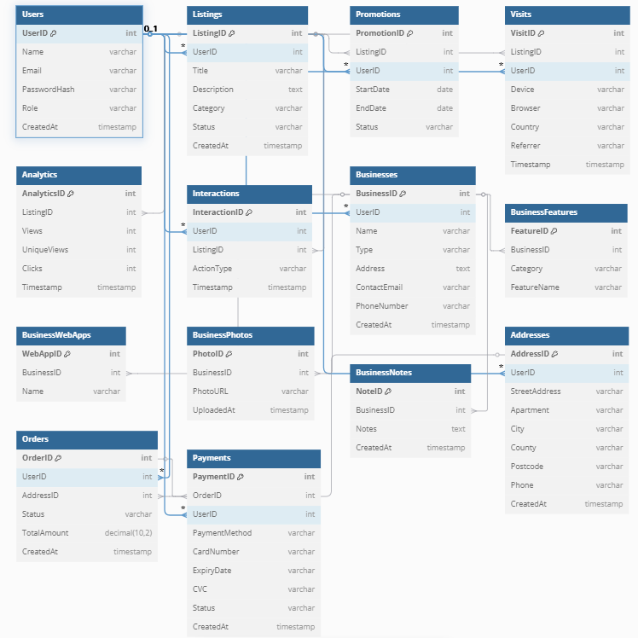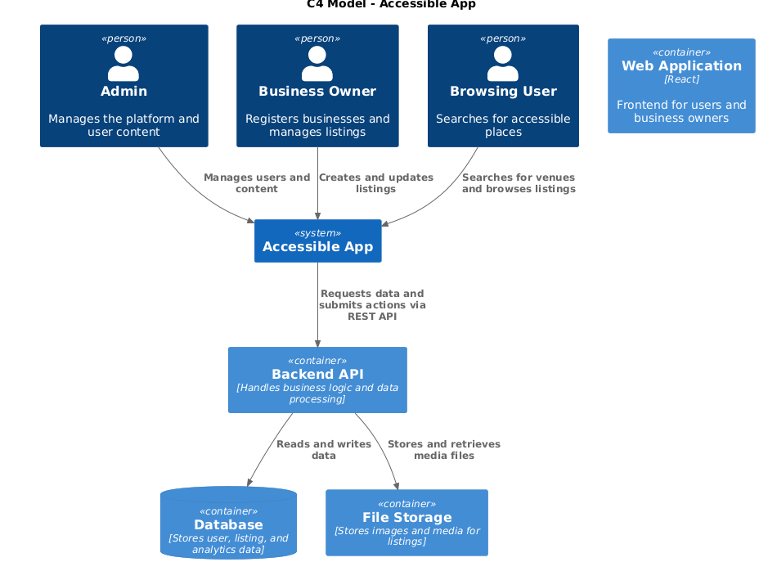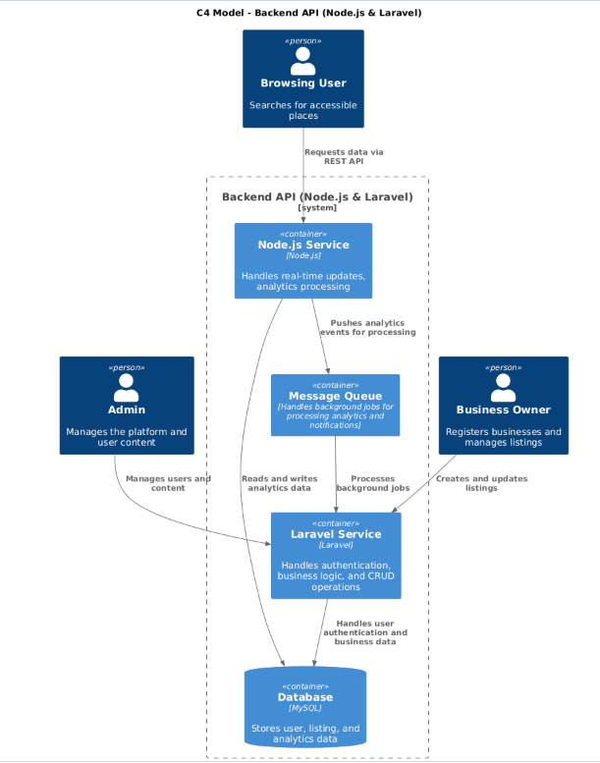

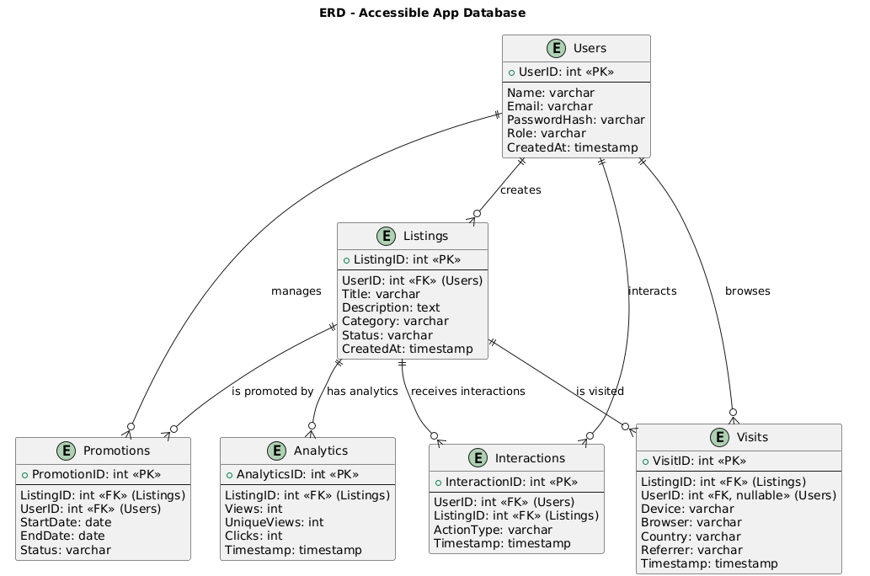

|  |  |  |
| --- | --- | --- |
| Task | Name | Finished (yes/no) |
| Footer | tasnim | yes |
| Nav Bar | Tasnim elliot jamie | yes |
| Form pages for businesses | Zara | yes |
| Accessible tourism page (to be accessed from the about page) | tasnim | yes |
| The ‘about’ page | tasnim | yes |
| The explore page |  |  |
| The resources page | Zara | yes |
| The search bar feature | Jamie |  |
| The alt text feature | zara | yes |
| The autosave feature | zara | yes |
| QR code |  |  |
| Database connection | Jamie | in progress |
| Payment Page | Igor | in progress |
| Payment Plugin |  |  |
| Tags for categorising pictures |  |  |
| Get accessminiguide page | tasnim | yes |
| Venue page | tasnim | yes |
| Event page | tasnim | yes |
| Mylistings page | tasnim | yes |
| EDR Diagram | Igor | yes |
| C4 Diagrams | Igor | yes |
| User Personas | Tasnim | yes |
| User stories | Igor | yes |
| Use Case Diagram | Igor |  |
| Software Requirement Specification Document | Tasnim/Igor | in progress |
| Miniguide page | tasnim | yes |